|  |  |
| --- | --- |
| Assignment 6  ITRI 623 | ENRICO DREYER  31210783 |

Table of Contents

Introduction 2

References in the poster 2

Reference List 2

# Introduction

For this assignment we were asked to create poster on Zookeeper, where we should clearly show typical functionality of monitoring tools. We should clearly state what functionality is supported and not supported by Zookeeper. We should also reflect on newer tools in this category. Text and screen shots will be supported by a source.

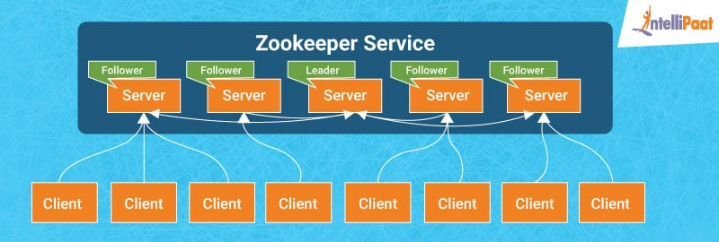

Figure 1: ZooKeeper Architecture (IntelliPaat, 2020)

The poster will be attached in the same zip file as this document in png and pdf format.

# References in the poster

1. Apache ZooKeeper, in short (offical, 2021).
2. What is Zookeeper (offical, 2021).
3. Apache Zookeeper Features (Flair, 2021).
4. Zookeeper Architecture (Tutors, 2019).
5. Zookeeper Architecture Components (IntelliPaat, 2020).
6. Typical functionality (IntelliPaat, 2020).
7. ZooKeeper Use Cases (Tutors, 2019).
8. Kafka Support (Dattel, 2021)
9. Newer Tools (AlternativeTo, 2021)

# Reference List

AlternativeTo. (2021). Apache ZooKeeper Alternatives. <https://alternativeto.net/software/apache-zookeeper/>

Dattel. (2021). What is ZooKeeper & How Does it Support Kafka? <https://dattell.com/data-architecture-blog/what-is-zookeeper-how-does-it-support-kafka/>

Flair, D. (2021). ZooKeeper Features | Why ZooKeeper Is So Popular. <https://data-flair.training/blogs/zookeeper-features/>

IntelliPaat. (2020). Why Do We Need Apache Zookeeper? <https://intellipaat.com/blog/what-is-apache-zookeeper/>

offical, A. Z. (2021). Welcome to Apache ZooKeeper. <https://zookeeper.apache.org/>

Tutors, H. (2019). What is Apache Zookeeper. <https://www.hopetutors.com/blog/big-data/what-is-apache-zookeeper/>